1. Tulis query untuk mendapatkan jumlah customer tiap bulan yang melakukan order pada tahun 1997.

**Jawab:**

* 1. Query

-- Query No. 1

SELECT MONTH(OrderDate) AS OrderMonth,

COUNT(DISTINCT CustomerID) AS CostumerCount

FROM Orders

WHERE YEAR(OrderDate) = 1997

GROUP BY MONTH(OrderDate);

* 1. Screenshot Output

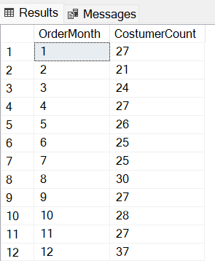

1. Tulis query untuk mendapatkan nama employee yang termasuk Sales Representative.

**Jawab:**

* 1. Query

-- Query No. 2

SELECT CONCAT(FirstName, ' ', LastName) AS EmployeeName, Title

FROM Employees

WHERE Title = 'Sales Representative';

* 1. Screenshot Output

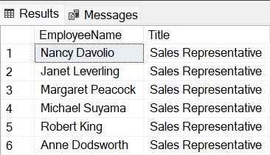

1. Tulis query untuk mendapatkan top 5 nama produk yang quantitynya paling banyak diorder pada bulan Januari 1997.

**Jawab:**

* 1. Query

-- Query No. 3

SELECT

TOP 5

Orders.OrderDate,

[Order Details].Quantity,

Products.ProductName

FROM Orders

INNER JOIN [Order Details] ON [Order Details].OrderID = Orders.OrderID

INNER JOIN Products ON [Order Details].ProductID = Products.ProductID

WHERE YEAR(OrderDate) = 1997 AND MONTH(OrderDate) = 1

ORDER BY Quantity DESC;

* 1. Screenshot Output

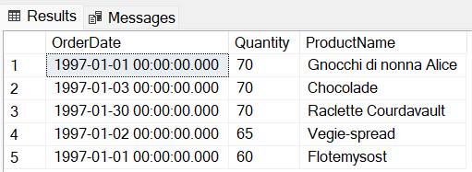

1. Tulis query untuk mendapatkan nama company yang melakukan order Chai pada bulan Juni 1997.

**Jawab:**

* 1. Query

-- Query No. 4

SELECT

Orders.OrderDate,

Products.ProductName,

Customers.CompanyName

FROM Orders

INNER JOIN [Order Details] ON [Order Details].OrderID = Orders.OrderID

INNER JOIN Products ON Products.ProductID = [Order Details].ProductID

INNER JOIN Customers ON Orders.CustomerID = Customers.CustomerID

WHERE YEAR(OrderDate) = 1997 AND MONTH(OrderDate) = 6

AND ProductName LIKE '%Chai%';

* 1. Screenshot Output

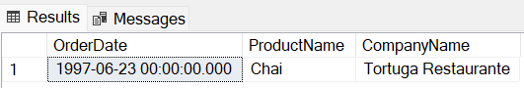

1. Tulis query untuk mendapatkan jumlah OrderID yang pernah melakukan pembelian (unit_price dikali quantity) <=100, 100<x<=250, 250<x<=500, dan >500.

**Jawab:**

* 1. Query

-- Query No. 5

SELECT

[Kategori Sales],

COUNT(OrderID) AS 'Jumlah OrderID'

FROM

(

SELECT Orders.OrderID,

CASE

WHEN ([Order Details].UnitPrice * [Order Details].Quantity) <= 100 THEN 'Dibawah 100'

WHEN ([Order Details].UnitPrice * [Order Details].Quantity) > 100

AND ([Order Details].UnitPrice * [Order Details].Quantity) <= 250 THEN 'Antara 100-250'

WHEN ([Order Details].UnitPrice * [Order Details].Quantity) > 250

AND ([Order Details].UnitPrice * [Order Details].Quantity) <= 500 THEN 'Antara 250-500'

WHEN ([Order Details].UnitPrice * [Order Details].Quantity) > 500 THEN 'Diatas 500'

END as "Kategori Sales"

FROM Orders

INNER JOIN [Order Details] ON [Order Details].OrderID = Orders.OrderID

) AS SalesCategoryTable

GROUP BY [Kategori Sales];

* 1. Screenshot Output

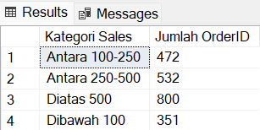

1. Tulis query untuk mendapatkan Company name pada tabel customer yang melakukan pembelian di atas 500 pada tahun 1997.

**Jawab:**

* 1. Query

-- Query No. 6

SELECT * FROM (

SELECT

Customers.CompanyName,

SUM([Order Details].UnitPrice * [Order Details].Quantity) AS 'TotalSales'

FROM Orders

INNER JOIN [Order Details] ON [Order Details].OrderID = Orders.OrderID

INNER JOIN Customers ON Customers.CustomerID = Orders.CustomerID

WHERE YEAR(OrderDate) = 1997

GROUP BY CompanyName

) AS CompanyNameTotalSales

WHERE TotalSales > 500;

* 1. Screenshot Output

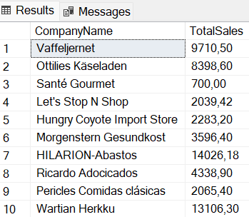

1. Tulis query untuk mendapatkan nama produk yang merupakan Top 5 sales tertinggi tiap bulan di tahun 1997.

**Jawab:**

* 1. Query

-- Query No. 7

WITH MonthlySales AS (

SELECT

Products.ProductName,

MONTH(Orders.OrderDate) AS Month,

SUM([Order Details].UnitPrice * [Order Details].Quantity) AS 'TotalSales'

FROM Orders

JOIN [Order Details] ON [Order Details].OrderID = Orders.OrderID

JOIN Products ON Products.ProductID = [Order Details].ProductID

WHERE YEAR(OrderDate) = 1997

GROUP BY MONTH(OrderDate), ProductName

)

SELECT

Month,

ProductName,

Rank

FROM (

SELECT

*,

ROW_NUMBER() OVER (PARTITION BY Month Order By TotalSales DESC) AS Rank

FROM MonthlySales

) AS MonthlyRankTable

WHERE Rank <= 5;

* 1. Screenshot Output

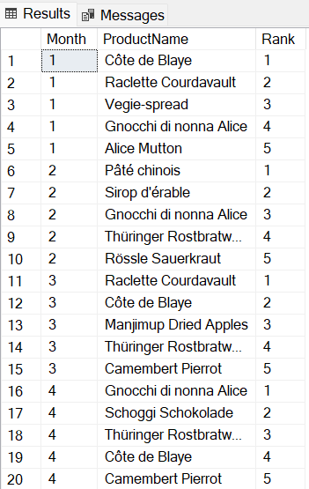

1. Buatlah view untuk melihat Order Details yang berisi OrderID, ProductID, ProductName, UnitPrice, Quantity, Discount, Harga setelah diskon.

**Jawab:**

* 1. Query

-- View No. 8

CREATE VIEW OrderDetailsView AS

SELECT

Products.ProductID,

Products.ProductName,

[Order Details].OrderID,

[Order Details].UnitPrice,

[Order Details].Quantity, [Order Details].Discount,

([Order Details].UnitPrice

* [Order Details].Quantity)

- ([Order Details].UnitPrice

* [Order Details].Quantity

* [Order Details].Discount) AS 'Harga setelah diskon'

FROM [Order Details]

JOIN Products ON Products.ProductID = [Order Details].ProductID;

* 1. Screenshot Output

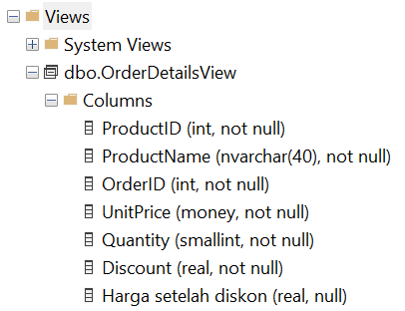

1. Buatlah procedure Invoice untuk memanggil CustomerID, CustomerName/company name, OrderID, OrderDate, RequiredDate, ShippedDate jika terdapat inputan CustomerID tertentu.

**Jawab:**

* 1. Query

-- Procedure No.9

CREATE PROCEDURE Invoice (@customerID INT)

AS

BEGIN

SELECT

Customers.CustomerID,

CONCAT(Customers.ContactName, ' / ', Customers.CompanyName) AS 'CustomerName/CompanyName',

Orders.OrderID,

Orders.OrderDate,

Orders.RequiredDate,

Orders.ShippedDate

FROM Customers

INNER JOIN Orders ON Customers.CustomerID = Orders.CustomerID

WHERE Customers.CustomerID = @customerID

END

* 1. Screenshot Output

